**Ansible inventory and variables**

* Assigning variables in inventory
  + Added group_vars and host_vars(https://github.com/asquarezone/AnsibleZone/commit/904364974708ba7de060121cf2f5b0d09abdc566)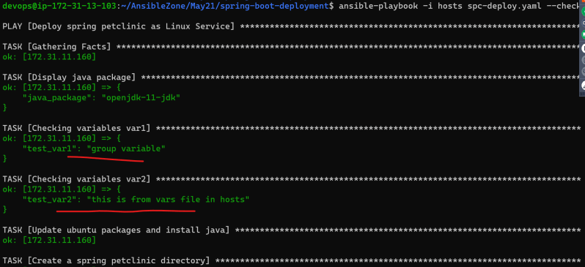
* Made changes to spring pet-clinic to have variables separated in a file (https://github.com/asquarezone/AnsibleZone/commit/a9cb8c8478c92d5563fd996cdef4763e43c6b629)
* In Ansible we have some behavioral inventory parameters
  + <https://github.com/asquarezone/AnsibleZone/commit/16b950e5259bee45122514164545b6c7315ff3f5> for example with ansible_host

**Scenario: Fail the ansible playbook execution if it executed on OS other than ubuntu**

* We need to understand the approach on how ansible finds out the information about node.
* Ansible has a module called as *setup* <https://docs.ansible.com/ansible/latest/collections/ansible/builtin/setup_module.html>
* For ansible conditional statement <https://docs.ansible.com/ansible/latest/user_guide/playbooks_conditionals.html>

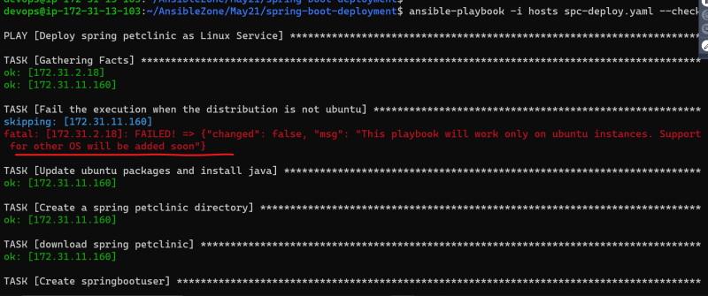

**Scenario: Show messages of what ansible is doing w.r.t application deployment to the user**

* We have added debug messages
* The message are execute and displayed every time 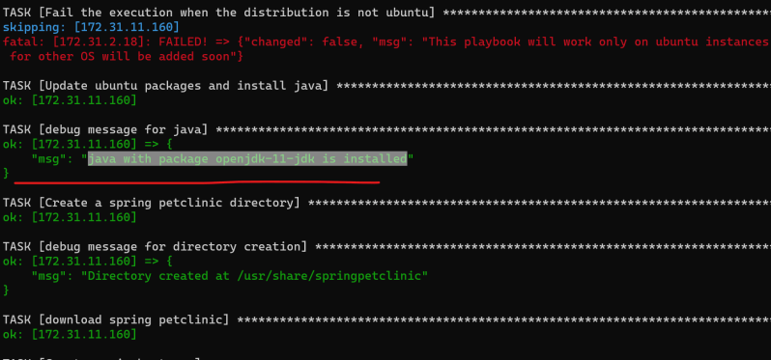
* We want to display the message only when the java is installed or when task actually makes the changes
* <https://github.com/asquarezone/AnsibleZone/commit/9b20e626d8478e8e641a595de87184ff73d540cc> for the changes

Screenshot:

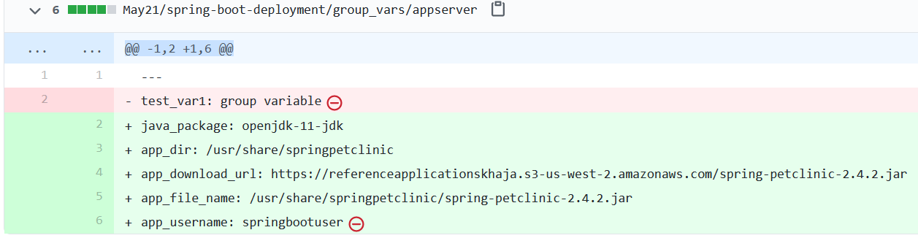

Conditional: <https://docs.ansible.com/ansible/latest/user_guide/playbooks_conditionals.html>

Handler: <https://docs.ansible.com/ansible/latest/user_guide/playbooks_handlers.html>

# Handlers: running operations on change

Sometimes you want a task to run only when a change is made on a machine. For example, you may want to restart a service if a task updates the configuration of that service, but not if the configuration is unchanged. Ansible uses handlers to address this use case.